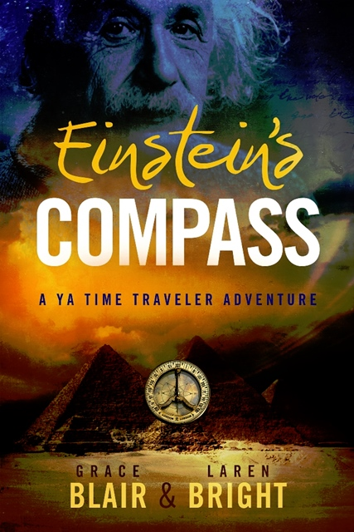
“I didn't arrive at my understanding of the fundamental laws of the universe through my rational mind.” – Albert Einstein

Where did Albert Einstein get his theories of light and time? Einstein’s Compass presents a fanciful adventure to answer that question.

Imagine Albert, as a young boy, receives a mystical compass that connects him to spiritual dimensions beyond human perception. Perhaps Albert, in an earlier incarnation, was a scientist in the ancient civilization of Atlantis and unconscious memories of that lifetime begin to influence his thinking as he explores his scientific theories.

“It is entirely possible that behind the perception of our senses, worlds are hidden of which we are unaware.” – Albert Einstein

To make things even more interesting, let’s add an immortal, genetically altered dragon doppelganger who can shapeshift. He’s in pursuit of Albert and his compass, so he can gain power and exert his dominion over the earth.

Einstein’s Compass deftly integrates historically accurate information about Albert Einstein, his work and his times, with elements of the fantastical. This young adult time travel novel ties it all together with respected theories about ancient Atlantis. It brings into focus how beings like Jesus, Akhenaten, Moses, Ezekiel, and other spiritual travelers might be watching over our planet and serving on the side of Light in the eternal tension between Light and Darkness.

“When you examine the lives of the most influential people who have ever walked among us, you discover one thread that winds through them all. They have been aligned first with their spiritual nature and only then with their physical selves.” – Albert Einstein

The story offers abundant opportunities to visually explore non-physical realms where souls go to learn and evolve. Set in 1900, Germany and Switzerland as fascism and anti-Semitism are growing across Europe, the story guides readers through the struggles Einstein might have faced at such a time in history. It also provides the opportunity to explore one of the most incredible minds of the 20th century—with abundant opportunities to visually explore non-physical realms where souls go to learn and evolve—like the lost continent of Atlantis.

Einstein’s Compass is a fascinating blend of the factual and the fantastical with enough of the metaphysical to leave readers wondering what is possible and what is a reality. Imagine that a Wrinkle in Time meets The Chronicles of Narnia with a little Harry Potter thrown into the mix.

“The more I learn of physics, the more I am drawn to metaphysics.”
– Albert Einstein

It is part science, part science fiction, part fantasy, part thriller, and all fun for young adults on up.

YouTube video: https://youtu.be/DHJ8O2Ah0no

YouTube Audiobook Sample: https://youtu.be/6WC5Jsgqvwg

YouTube video: https://youtu.be/NCz8Pd9YxvY

Marketing for Einstein’s Compass began in July 2016 on a social media platform www.Bublish.com to date more than 200,000 people have read chapter snippets on my Bublish platform https://bublish.com/author/graceblair

Sales of Einstein’s Compass from January 2019 – July 2019
250 paperback, eBook and audiobooks sold.

June 9, 2019, ranked #79 Amazon Young Adult Historical Fantasy.

Grace Blair, Author
Einstein’s Compass a YA Time Traveler Adventure
4408 14 Street
Lubbock, Texas 79416
806-790-4845

